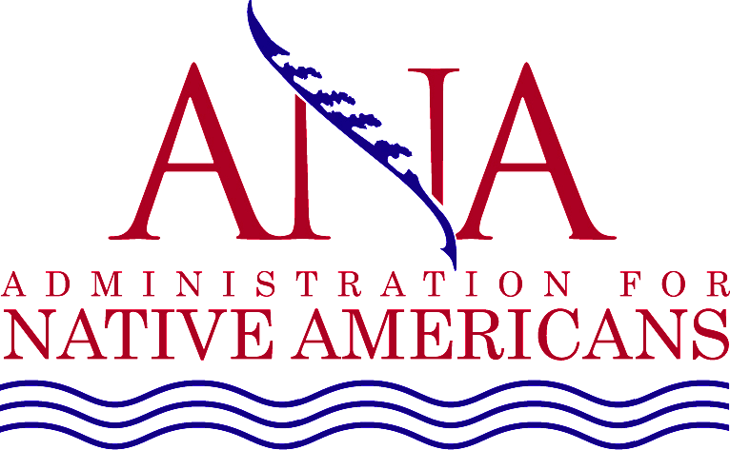

**For reservations:** Please call (405) 601-1700 make your reservations and request the group rate for

**Post Award Training**. You may also [click here](https://nam10.safelinks.protection.outlook.com/?url=https%3A%2F%2Fwww.marriott.com%2Fevents%2Fstart.mi%3Fid%3D1662061106247%26key%3DGRP&data=05%7C01%7Ctracy.swibold%40atriumhospitality.com%7Cd7dbe98be32841071ae508da8c51963a%7C2a940736346f4580951607fd1e7cc52d%7C0%7C0%7C637976579297252272%7CUnknown%7CTWFpbGZsb3d8eyJWIjoiMC4wLjAwMDAiLCJQIjoiV2luMzIiLCJBTiI6Ik1haWwiLCJXVCI6Mn0%3D%7C3000%7C%7C%7C&sdata=hJKEXUM9BBIGRcfsaCmzzZbskI2XboS7B20I%2BFD21MU%3D&reserved=0) to book online.

Room rate: The room rate is $104.00 plus tax per night. The room block cutoff date is **September 12th,** after that date we cannot guarantee the group rate will be available.

**Reservations must be guaranteed**: All reservations must be guaranteed and accompanied by a first night’s room deposit or guaranteed with a major credit card. The hotel will not hold any reservation unless secured by one of the above methods.

Reservation cancellation: If you cancel your reservation, the deposit is refundable if notice is received 2 days prior to your arrival.

**Native Language Summit** will be held on October 4, 2022, at the Oklahoma City Convention Center which is located 0.3 miles from the hotel. [Click here](https://goo.gl/maps/L9yQoHHKzE7pz7dt7) for directions.

***Sche******dule***

Please plan to arrive in Oklahoma City on Monday, October 3 if you are attending the Native Language Summit or October 4th if you are attending the Post Award training. Departure is on October 6 for those not attending NIEA or depart on Saturday, October 9 if you are attending NIEA. If you are not local, you will need to book your hotel reservations. The closing date for hotel reservations at the Post Award rate is Monday, September 12, 2022.

[**Click here to Register**](https://www.eventbrite.com/e/native-language-summit-speaking-sovereignty-tickets-404806195227)

[**Click here to Register**](https://anawestern.org/training/22-lang-postaward/)

**Language Post Award Training**

**OCTOBER 5, 2022**

Residence Inn Bricktown

400 E Reno Ave, Oklahoma City, OK 73104

(405) 601-1700

**Language Post Award** registration will start at 8:00 a.m. on Wednesday, October 5 outside the Centennial I &

II meeting room. Trainings will start at 8:30 a.m. CT each day and will run until 5:00 p.m CT. Lunch break is

approximately noon – 1:00 p.m. and are on your own.

**Accommodations:** Residence Inn Bricktown

•

•

•

•

•

**Check In**:

3:00 p.m.

**Check Out:**

12:00 p.m.

***Transportation***

•

The nearest airport is Oklahoma City-Will Rodgers International Airport (OKC).

***Driving Directions***

•

For transportation and driving directions [click](https://www.bing.com/maps?osid=3af25955-7f03-4dbb-8d50-92dcb8f510d5&cp=35.433809~-97.578812&lvl=12&v=2&sV=2&form=S00027) here.

***Weather***

•

Click [here](https://www.accuweather.com/en/us/oklahoma-city/73102/weather-forecast/350143) to see the weather forecast for your visit to Oklahoma City, OK

**Native Language Summit**

**Tuesday, OCTOBER 4, 2022**

Oklahoma City Convention Center

100 Mick Cornett Dr, Oklahoma City, OK 73109