Pre-Application Training – Activity Workbook
Many of these activities can be found in your Manual. We have made them easier to access here. We have also included additional activities not included in the Manual to allow you to practice key concepts that will be introduced in the training.

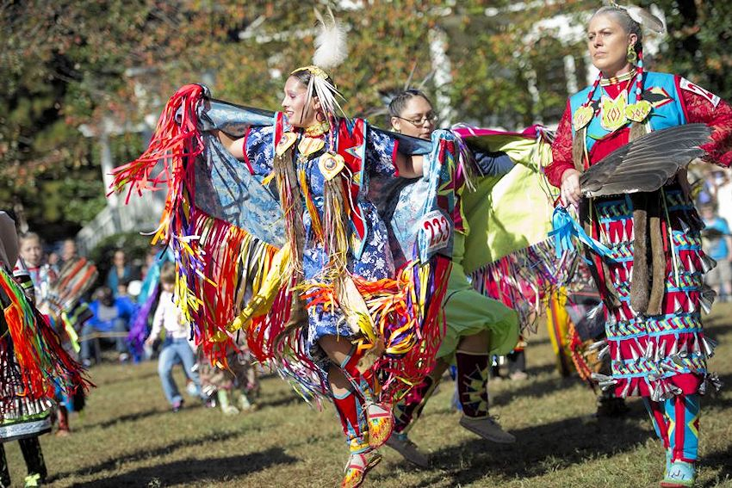

DAY ONE:
Describe your project in one sentence:

Long-term Community Goal
Write your long-term community goal statement identified for this project:

Briefly describe how the proposed project was selected and how it will bring the community closer to reaching the long-term community goal. (Identify where this statement is found – for example: comprehensive plan documents, mission statements, vision statements, strategic planning documents, or other sources):

Current Community Condition
Restate your long-term community goal:

Write the Current Community Condition Statement that is addressed by the scope of the proposed project:
Provide the status of the current community condition (baseline information):

What sources were used?

Project Goal
Describe how your project goal statement relates to the purpose of the FOA:

Objectives
Write a TTIP Objective:

What is your timeline:

What is your Target:

What is your Indicator:

Who is your population:

Describe the objective’s measurable achievement with all its components (target, timeline, and indicator:

Describe how all your objectives lead to the achievement of the project goal (no more than 3 objectives):

Outcomes
Project Goal:

Outcome for Objective 1:

Target + Indicator for Objective 1:

Narrative Explanation:

Outcome for Objective 2:

Target + Indicator for Objective 2:

Narrative Explanation:

Outcome for Objective 3:

Target + Indicator for Objective 3:

Narrative Explanation:

Outputs
Objective 1:

List Your Outputs | Describe their Significance | When do you need the output

Objective 2:

List Your Outputs | Describe their Significance | When do you need the output

Objective 3:

List Your Outputs | Describe their Significance | When do you need the output

DAY TWO:
Outcome Tracker(s)
Project Outcome Tracker
Long-term Community Goal:

Current Community Condition:

Project Goal:

Objective 1:

Outcome | Indicator | Means of Measurement | Baseline | Yr. 1 | Yr. 2 | Yr. 3 | 3-Years Post Project
Outputs:

Required Elements | Consider the Following
Means of Measurement | What method will be used to measure the change of the objective?
Baseline | What is the starting point for the target being measured?
Benchmark targets for the end of each project year (if applicable)  Project Year 1  Project Year 2  Project Year 3 (End of Project)  3-year Post Project | What is the estimated amount of change to be seen each year?

Project Outcome Tracker
Long-term Community Goal:

Current Community Condition:

Project Goal:

Objective 2:

Outcome | Indicator | Means of Measurement | Baseline | Yr. 1 | Yr. 2 | Yr. 3 | 3-Years Post Project
Outputs:

Project Outcome Tracker
Long-term Community Goal:

Current Community Condition:

Project Goal:

Objective 3:

Outcome | Indicator | Means of Measurement | Baseline | Yr. 1 | Yr. 2 | Yr. 3 | 3-Years Post Project
Outputs:

Outcome Tracking Strategy
Describe the details of the outcome tracking plan for the project answering the 5Ws: Who will do the tracking? What will they track, and what will they use to track it? Where will the gather the information from, and where will they keep it? When will they track it? How will the track it?

Objective Work Plan
Below is a table to get started. This is NOT official. Please refer to the official OWP Form that can be found on Grants.gov for a complete, fillable form. You should have one form per objective per year.

Project Title:
Project Goal:
Project Year:
Objective #__:

Outcome:

Milestone Activities | Outputs | Project Staff | Start Date | End Date
Lead:

Support:

Lead:

Support:

Lead:

Support:

Lead:

Support:

Lead:

Support:

Community Based Strategies
Use the table below to outline the narrative for this element:
Type of Involvement (activity, meeting, gathering, survey, etc.) | Who was Involved | Process(es) used for Involvement | Documentation to attach to the application (suggested)

Write a narrative to describe what is noted in the above table:

Describe the working history your organization has with the community to be served:

Describe past experience with (similar) project participants and/or beneficiaries and how it relates to the ANA project’s participants/beneficiaries:

Create an ongoing outreach plan:
Message or Purpose of the Outreach | Target Audience | Media to be used | Person Responsible for Creation | Person Responsible for Dissemination | Timeframe

Write a narrative that describes the plan above:

Readiness and Implementation
Determine the resources and services needed for the project. Check where it is available or if you need to obtain it:
Available | Obtain | Resource/Service | Source/Location | Cost/Value ($)

Write a narrative describing the above table:

Brainstorm your Milestone Activities:
Milestone Activity | Tasks | Outputs | Person(s) Responsible | Timeline

*The table above is for brainstorming activities. This is NOT the form to use for your Objective Work Plan. Milestone activities do not include Required Administrative Activities defined by the FOA and by the OWP instructions (including, Establishing the Grant File, Staff Orientation, Reporting, etc.).

Recruiting and Selecting Participants
Criteria for Selecting Participants | Incentives for Participation | Retention Strategy

Use the table below to outline your sustainability plan:
Outcome:

Identify: | Describe how the outcome will be sustained:
Resources

Staff

Partners

Other

Identify possible obstacles and challenges and then develop a contingency for each:
Key Activity:
Potential Obstacle:
Contingency Plan:
Key Activity:
Potential Obstacle:
Contingency Plan:
Key Activity:
Potential Obstacle:

Contingency Plan:

DAY THREE:
Organizational Capacity
Describe a staffing and organizational structure that will support full implementation upon receipt of the award by describing the identification of the PI/PD, project staff, and a timeframe and strategy for filling vacant positions:

Describe how you will show the combined, knowledge, experience and capabilities (using resumes) of the proposed PI/PD, key project staff and key partners is sufficient to carry out the proposed project:

Fill in the table below for all Key Staff positions:
Key Staff Position | Person (if identified) | Qualifications | Roles/Responsibilities | Supporting Document to attach | Expected Hire Date
PI/PD

Fill in the table below for all Key Partner positions:
NOTE: Partners are entities that are invested in the success of your project. Internal partners (from your organization) and external partners (from other organizations) are valuable resources in project planning and implementation. Consultants can fill expertise gaps and help build organizational capacity. Include statements of qualifications for proposed partners or consultants that document their expertise to perform their assigned project tasks.
Key Partner or Consultant | Qualifications and  Selection | Roles/Responsibilities | Staff overseeing  partner | Supporting Document to Attach | How will work be sustained

Write a narrative describing your plans for engaging, overseeing, and sustaining the work of partners and consultants:

Briefly describe a plan for financial oversight of Federal Awards for your Tribe or Organization:

Budget and Budget Justification
Line-Item Budget-detail federal and non-federal shares for each year. Personnel should be delineated by full-time equivalency or percentage of time on the project. Include all funds to successfully implement the project budget.
Complete a line-item budget for each year of the project:
BUDGET YEAR ONE
CATEGORY/ITEM DESCRIPTION | Federal Share | Non-Federal Share | Total
PERSONNEL
TOTAL PERSONNEL
FRINGE BENEFITS
FICA @ 7.65%
FUTA @ 6%
SUTA @ 3.17%
Medicare
Health Insurance @ 10%
TOTAL FRINGE BENEFITS
TRAVEL
Post Award Training
ANA Grantee Meeting
TOTAL TRAVEL
EQUIPMENT
TOTAL EQUIPMENT
SUPPLIES
TOTAL SUPPLIES
CONTRACTUAL
TOTAL CONTRACTUAL
OTHER
TOTAL OTHER
DIRECT COST TOTAL
INDIRECT COST @ XX% (if applicable)
TOTAL PROJECT COST YEAR 1

Provide a narrative description of each line-item cost including how the costs are calculated for each entry. The budget justification includes a rationale for estimating costs, vender quotes for major supplies and all equipment, and supporting documentation to detail the required commitment of the non-federal (cost sharing or matching) contributions. The budget justification describes how expenditures align with the Approach and the OWP.
BUDGET YEAR ONE
CATEGORY/ITEM DESCRIPTION | Federal Share | Non-Federal Share | Calculation and Justification
PERSONNEL | $ | $
FRINGE BENEFITS | $ | $
FICA @ 7.65%
FUTA @ 6%
SUTA @ 3.17%
Medicare
Health Insurance @ 10%
TRAVEL | $ | $
Post Award Training
ANA Grantee Meeting
EQUIPMENT | $ | $
SUPPLIES | $ | $
CONTRACTUAL | $ | $
OTHER | $ | $
DIRECT COST TOTAL | $ | $
INDIRECT COST @ XX% (if applicable) | $ | $
TOTAL PROJECT COST YEAR 1 | $ | $

